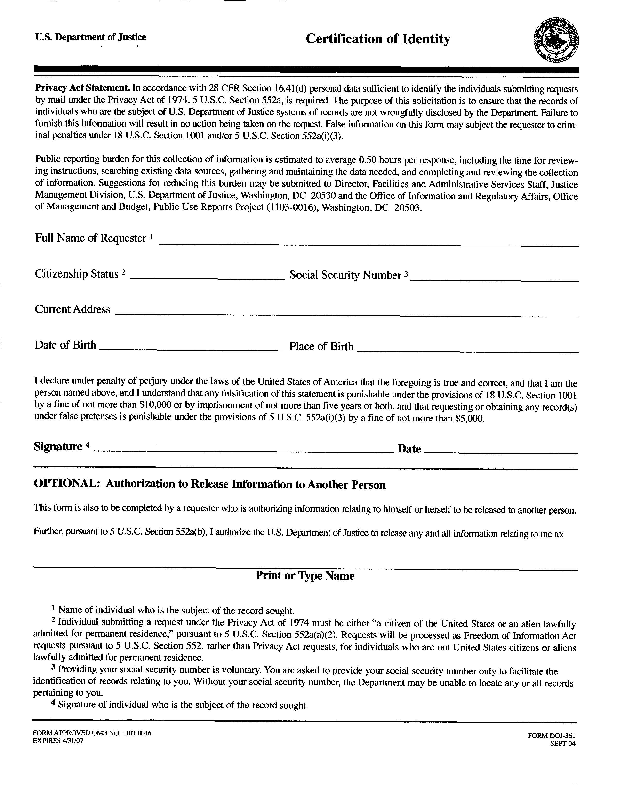

Order No. 01-22304 - 044
Robert McKinney
XXX-XX-5648
David Weiser, Esquire, Crisci, Weiser & Huenke c/o Axiom Requisition Copy Service, 2869 Jolly Rd, Okemos, Michigan 48864 (877) 886-5090 / (517) 886-4116 Fax

06/25/1968

